* My Github Account Name: littlesnail1982
* My Design Pattern:

Command:

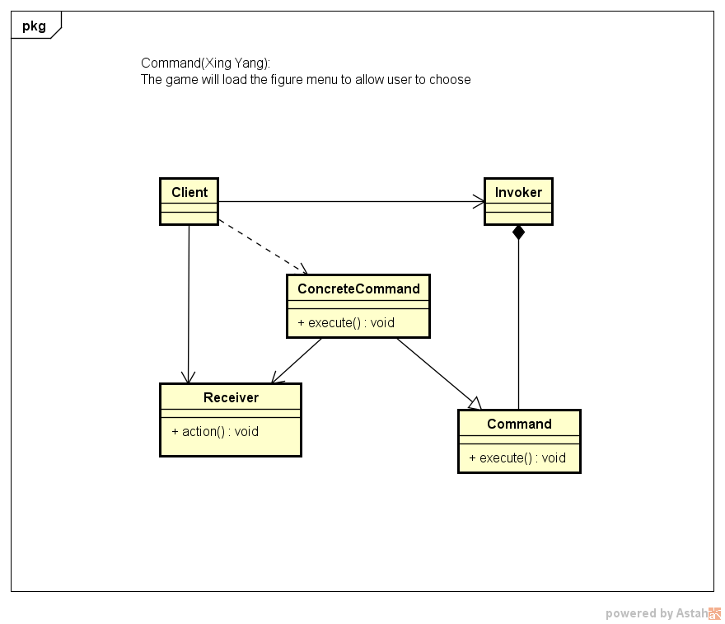

* The XP Core Value I am Advocating:

Simplicity: This week, we only focus on two figures: Bruce Lee and one enemy. We make sure that Bruce Lee could move and punch, enemy could move and when Bruce Lee is near him, it could automatically punch. We have not considered any weapons for figures and we also not add power or blood conditions to these figures. Except that, we use fix background for every level. For the images for games, we firstly use some dummy images instead to make sure the main function is correct. After the basic function could work with no bug, we will add the different strategies to figures like the figure will have different number of lives, the figure could have weapons when his blood above some value, or the move speed will get lower and lower when his strength getting weaker and weaker. We will also try to make background move when the figure move, try to make more image frames for one action. Then we will make a code review and code refactor based on this benchmark. After that, we will add more figures and background. And if we still have time, we may allow the user to choose hardness of the playing, like easy, medium or hard.